1. Write a program to simulate Peterson’s solution.

Code:

#include <iostream>

#include<thread>

#include<atomic>

using namespace std;

const int NUM_THREADS = 2;

atomic<int> turn;

atomic<bool> flag[NUM_THREADS];

void lock(int threadId) {

    int other = 1 - threadId;

    flag[threadId].store(true);

    turn.store(other);

    while (flag[other].load() && turn.load() == other) {

    }

}

void unlock(int threadId) {

    flag[threadId].store(false);

}

void criticalSection(int threadId) {

    cout << "Thread " << threadId << " is in critical section." << endl;

    this_thread::sleep_for(chrono::milliseconds(100));

}

void threadFunction(int threadId) {

    for (int i = 0; i < 5; ++i) {

        lock(threadId);

        criticalSection(threadId);

        unlock(threadId);

        this_thread::sleep_for(chrono::milliseconds(50));

    }

}

int main() {

    turn.store(0);

    flag[0].store(false);

    flag[1].store(false);

    thread t1(threadFunction, 0);

    thread t2(threadFunction, 1);

    t1.join();

    t2.join();

    return 0;

}

Output:

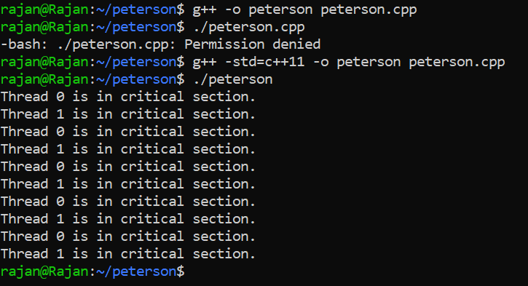

2. Write a program to avoid racing conditions using semaphore.

Code:

#include <stdio.h>  
#include <stdlib.h>  
#include <pthread.h>  
#include <semaphore.h>  
  
#define NUM_THREADS 2  
#define COUNT 10  
  
int shared_variable = 0;  
sem_t semaphore;  
  
void *thread_function(void *arg) {  
    int thread_id = *((int *)arg);  
  
    for (int i = 0; i < COUNT; ++i) {  
        sem_wait(&semaphore);  // Wait until semaphore is available  
  
        // Critical section  
        printf("Thread %d in critical section (iteration %d)\n", thread_id, i+1);  
        shared_variable++;  
        printf("Shared variable value after increment: %d\n", shared_variable);  
  
        sem_post(&semaphore);  // Release semaphore  
    }  
  
    pthread_exit(NULL);  
}  
  
int main() {  
    pthread_t threads[NUM_THREADS];  
    int thread_ids[NUM_THREADS] = {0, 1};  
  
    sem_init(&semaphore, 0, 1);  // Initialize semaphore with initial value 1  
  
    // Create threads  
    for (int i = 0; i < NUM_THREADS; ++i) {  
        int result = pthread_create(&threads[i], NULL, thread_function, &thread_ids[i]);  
        if (result != 0) {  
            fprintf(stderr, "Error creating thread %d\n", i);  
            return 1;  
        }  
    }  
  
    // Join threads  
    for (int i = 0; i < NUM_THREADS; ++i) {  
        pthread_join(threads[i], NULL);  
    }  
    sem_destroy(&semaphore);  // Destroy semaphore  
    return 0;  
}

Output:

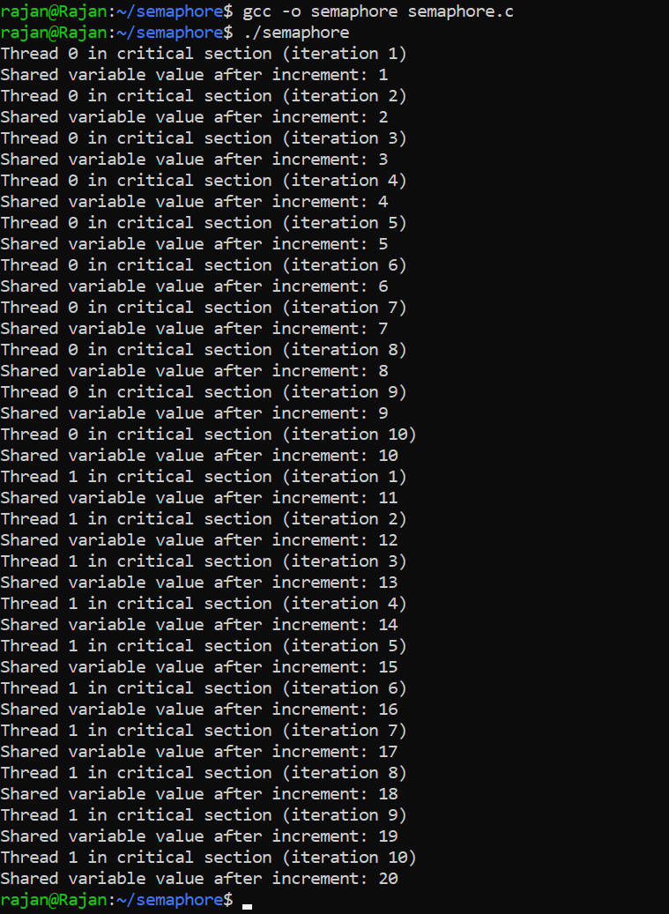

3. WAP to simulate producer consumer problem using mutex.

Code:

#include <stdio.h>  
#include <stdlib.h>  
  
// Initialize a mutex to 1  
int mutex = 1;  
  
// Number of full slots as 0  
int full = 0;  
  
// Number of empty slots as size  
// of buffer  
int empty = 10, x = 0;  
void producer()  
{  
    // Decrease mutex value by 1  
    --mutex;  
  
    // Increase the number of full slots by 1  
    ++full;  
  
    // Decrease the number of empty slots by 1  
    --empty;  
  
    // Item produced  
    x++;  
    printf("\nProducer produces item %d”, x);  
  
    // Increase mutex value by 1  
    ++mutex;  
}  
  
void consumer()  
{  
    // Decrease mutex value by 1  
    --mutex;  
  
    // Decrease the number of full slots by 1  
    --full;  
  
    // Increase the number of empty slots by 1  
    ++empty;  
    printf("\nConsumer consumes "  
           "item %d",  
           x);  
    x--;  
  
    // Increase mutex value by 1  
    ++mutex;  
}  
  
int main()  
{  
    int n, i;  
    printf("\n1. Press 1 for Producer"  
           "\n2. Press 2 for Consumer"  
           "\n3. Press 3 for Exit");  
#pragma omp critical  
    for (i = 1; i > 0; i++) {  
        printf("\nEnter your choice:");  
        scanf("%d", &n);  
        switch (n) {  
        case 1:  
            if ((mutex == 1)  
                && (empty != 0)) {  
                producer();  
            }  
            else {  
                printf("Buffer is full!");  
            }  
            break;  
  
        case 2:  
            if ((mutex == 1)  
                && (full != 0)) {  
                consumer();  
            }  
            else {  
                printf("Buffer is empty!");  
            }  
            break;  
        case 3:  
            exit(0);  
            break;  
        }  
    }  
}

Output:

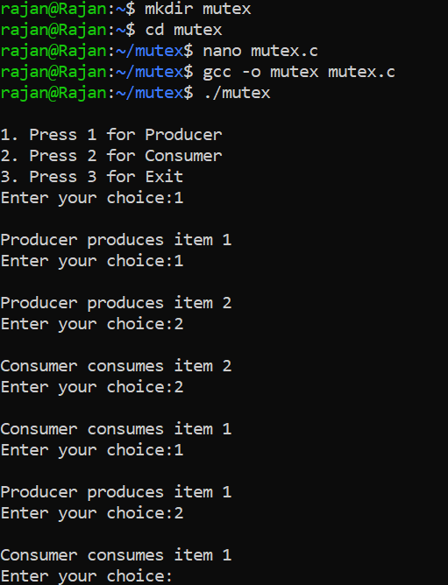

4. Write a program using fork system call such that parent process should calculate the sum of the two numbers and child process should calculate the multiplication of the same number.

Code:

#include <iostream>  
#include <unistd.h>  
using namespace std;

int main() {  
    int num1, num2;  
    cout << "Enter two numbers: ";  
    cin >> num1 >> num2;  
    pid_t pid = fork();  
  
    if (pid < 0) {  
        cout << "Fork failed!" << endl;  
        return 1;  
    }  
  
    if (pid > 0) {  
        int sum = num1 + num2;  
        cout << "Parent process:\n";  
        cout << "Sum of " << num1 << " and " << num2 << " is " << sum << endl;  
    } else {  
         
        int product = num1 * num2;  
        cout << "Child process:\n";  
        cout << "Product of " << num1 << " and " << num2 << " is " << product << endl;  
    }  
  
    return 0;  
}

Output:

